LAB # 1
Introduction to GitHub
OBJECTIVE
Performing commit, push, and pull operations from eclipse repository and analyzing version changes on Git repository.

Lab Task:
Create account on GitHub, add a clone git repository in eclipse and push the java project on GitHub.
Code:
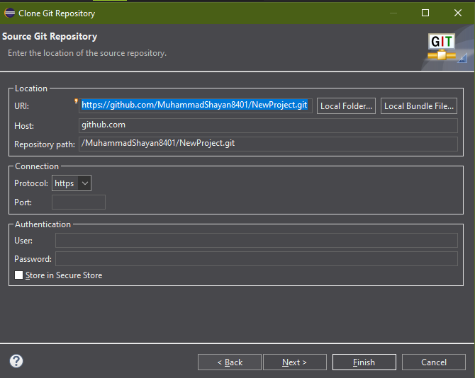
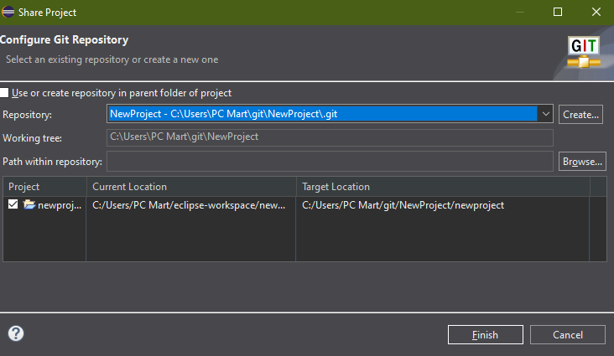

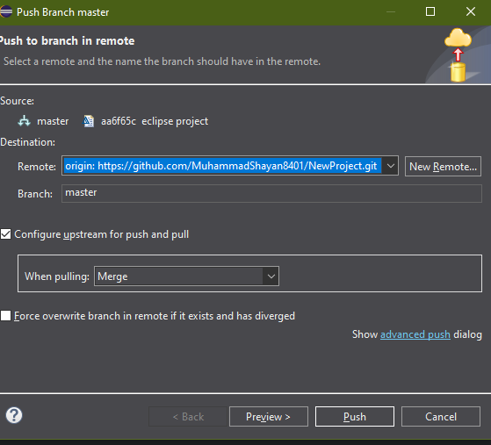
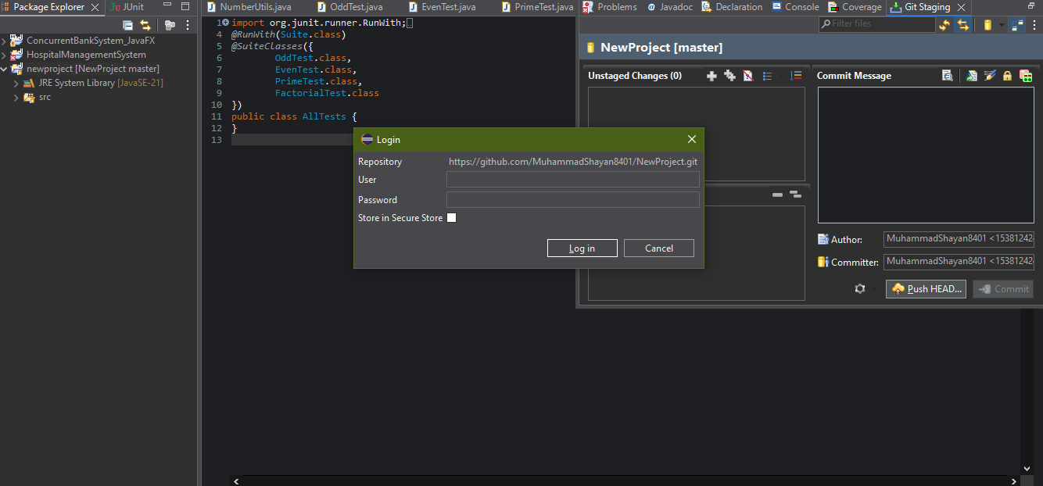
Github Screenshot:

